INTELLIGENT DISASTER EARLY WARNING AND
EVACUATION MANAGEMENT SYSTEM
An AI, IoT and GIS-Based Disaster Management Platform
Cyclone-Induced Flooding in Odisha, India
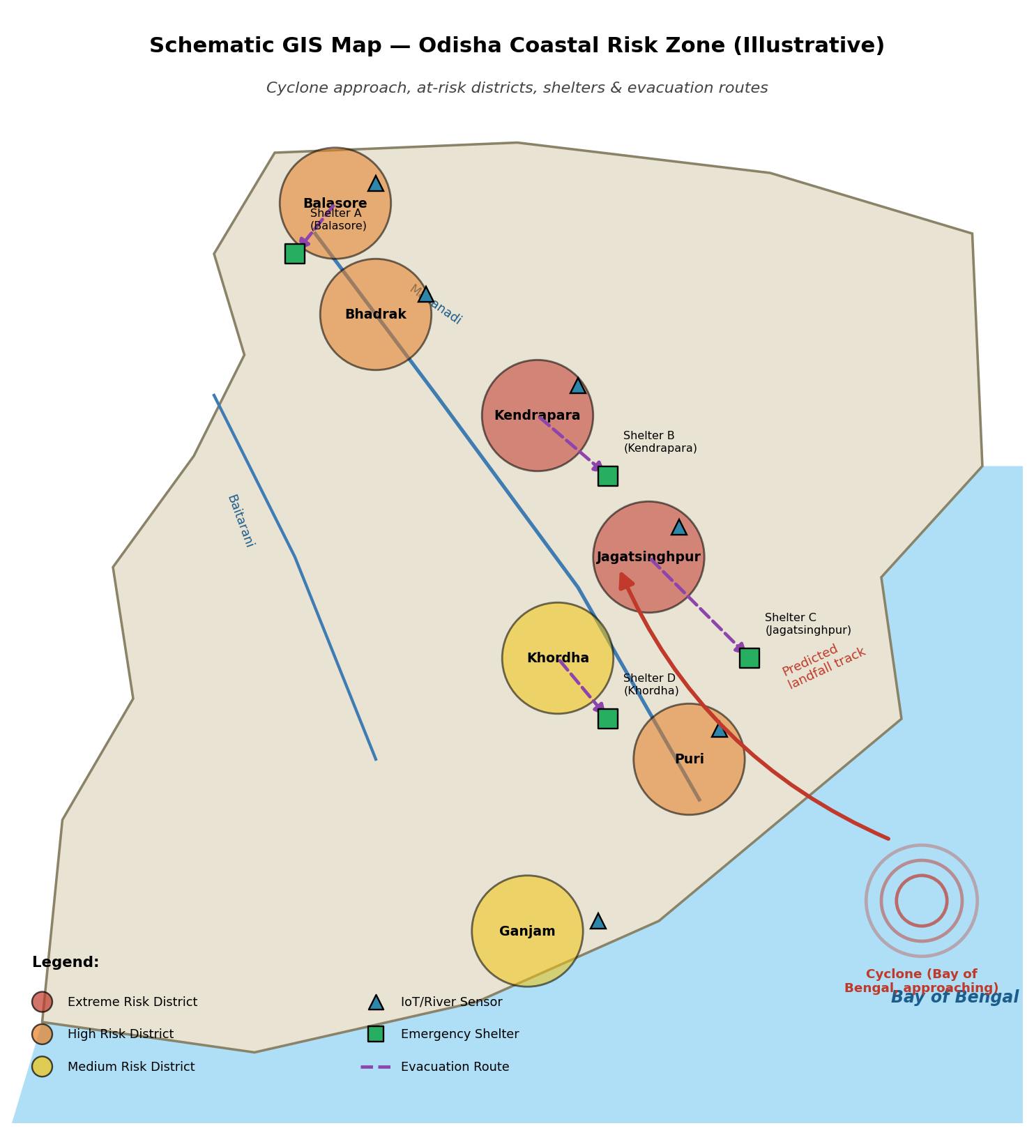

Course / Subject | CSA1017-Software Engineering
Team Number
Assignment | Intelligent Disaster Early Warning and Evacuation Management System
Team Members | Yeleti Rishitha-192424233, Manisha M-192424130, Loshini L-192571015, Indhu-192524332, Bindhu-192524472, Balaji K-192511404, Pittam Parthasaradhi Reddy-192372226
Institution | SIMATS Engineering
Submitted To | Dr Latha
Date of Submission | 01/09/2026

1. Problem Statement
Problem Statement:
Odisha's 480-kilometre coastline along the Bay of Bengal makes it one of the most cyclone-prone states in India, regularly experiencing cyclone-induced flooding in low-lying coastal districts such as Balasore, Bhadrak, Kendrapara, Jagatsinghpur, Puri, Khordha and Ganjam. Events such as the 1999 Odisha Super Cyclone, Cyclone Phailin (2013), Cyclone Fani (2019) and Cyclone Yaas (2021) demonstrate a recurring pattern: a cyclone forms in the Bay of Bengal, intensifies, makes landfall on the Odisha coast, and triggers heavy rainfall that causes rivers such as the Mahanadi, Baitarani and Subarnarekha to overflow, flooding densely populated areas.
Despite considerable improvement in cyclone tracking by the India Meteorological Department (IMD) and the Odisha State Disaster Management Authority (OSDMA), the existing warning-to-evacuation chain still suffers from delayed data fusion across heterogeneous sensor networks, a lack of automated, hyper-local risk prediction, fragmented communication channels for alerting citizens, manual and often outdated evacuation-route and shelter-allocation decisions, and poor real-time visibility for coordinating multiple agencies (police, fire and rescue, medical teams, NDRF/ODRAF and relief organisations). These gaps result in delayed warnings, congested or unsafe evacuation routes, overcrowded or under-resourced shelters, and avoidable loss of life and property.
The problem addressed by this project is therefore: how can real-time multi-source sensor data, Artificial Intelligence / Machine Learning-based prediction, GIS-based spatial analysis and multi-channel communication be integrated into a single coordinated platform that reduces the time between hazard onset and safe evacuation, specifically for cyclone-induced flooding scenarios in coastal Odisha?
Assignment Title: Intelligent Disaster Early Warning and Evacuation Management SystemThe problem can be formally framed as a data-to-decision pipeline with the following components:
Component | Description
Inputs (X) | Real-time streams from IoT river-level sensors, automatic weather stations (rainfall, wind speed, pressure), seismic/environmental sensors, satellite and IMD cyclone-track data, tidal data and citizen-submitted incident reports.
Model (f) | An AI/ML risk-prediction function f(X) → R that maps live sensor readings for a district/village to a continuous flood/cyclone risk score R ∈ [0, 100].
Decision Rule | A threshold-based classifier that converts R into a discrete risk level (Low / Medium / High / Extreme) and triggers alerting when R exceeds a configurable threshold θ.
Spatial Optimisation | A GIS-based function that, given the set of at-risk locations, road network, traffic and population density, computes safe zones, evacuation routes and nearest-available shelters with sufficient capacity.
Outputs (Y) | Multi-channel alerts (App, SMS, Email, sirens), recommended evacuation routes, shelter assignments, and a real-time operational picture on the authority dashboard and citizen mobile app.
Objective | Minimise the time between hazard detection and completed evacuation, while maximising warning accuracy (precision/recall) and shelter-resource utilisation efficiency, subject to real-world constraints of connectivity, road capacity and shelter capacity.

2. Objective and Expected Outcomes
- Develop an AI/ML-based prediction model that estimates cyclone-induced flood risk for coastal Odisha districts from real-time sensor, weather and satellite data.
- Integrate heterogeneous monitoring systems (IoT river/water-level sensors, weather stations, seismic sensors, satellite feeds) into a unified cloud data pipeline.
- Provide rapid, location-specific, multi-channel alerts (mobile app, SMS, email, web, sirens) to citizens and authorities.
- Design a GIS-based module to identify affected areas, safe zones and optimal evacuation routes considering severity, road conditions, traffic and population density.
- Monitor emergency-shelter location, occupancy, facilities, food and medical supplies to support effective resource allocation.
- Build a centralised, real-time dashboard for disaster-management authorities to monitor conditions, risk levels, evacuation progress and rescue operations.
- Enable citizen participation through a mobile application for receiving alerts, locating shelters, following evacuation routes and reporting incidents.
- Improve inter-agency coordination among government authorities, police, fire and rescue, medical teams and relief organisations.
Expected Outcome | How the System Delivers It
Faster disaster detection | Earlier identification of high-risk conditions through continuous AI-based monitoring rather than periodic manual review.
Improved emergency response | Reduced time between risk detection and dispatch of rescue/medical teams via automated coordination.
Optimised evacuation | Shorter, safer evacuation routes computed dynamically from live traffic, road-condition and population data.
Efficient resource allocation | Shelters allocated based on real-time capacity, food and medical-supply status, reducing overcrowding.
Better authority–citizen communication | Consistent, verified, multi-channel information flow reduces panic and misinformation.
Reduced casualties and property damage | Earlier warnings and organised evacuation reduce exposure to flood hazards.
Enhanced community resilience | Historical data and post-event analytics support better preparedness for future cyclone seasons.
Table 2.1 — Mapping of expected outcomes to system capabilities

3. Requirements:
ID | Requirement
FR-1 | The system shall ingest real-time data from IoT river-level sensors, weather stations, seismic sensors, satellite feeds and citizen reports.
FR-2 | The system shall compute a flood/cyclone risk score per district/village using an AI/ML model.
FR-3 | The system shall issue multi-channel alerts (app push, SMS, email, web, siren API) when risk exceeds a configurable threshold.
FR-4 | The system shall generate GIS-based maps of affected areas, safe zones and optimal evacuation routes.
FR-5 | The system shall track shelter location, capacity, occupancy, food and medical-supply status.
FR-6 | The system shall provide a real-time dashboard for authorities showing risk levels, evacuation progress and shelter status.
FR-7 | The system shall allow citizens to view alerts, locate shelters, view evacuation routes and submit incident reports (with photo and GPS) via a mobile app.
FR-8 | The system shall support role-based access for different agencies (police, fire, medical, relief, administrators).
FR-9 | The system shall log all alerts, decisions and responses for post-event audit and analysis.
Table 3.1 — Functional requirements
Category | Requirement
Performance | Risk scores and alerts shall be generated within a few seconds of data ingestion; dashboard updates shall reflect near real-time status (≤ 30 s latency target).
Scalability | The cloud back end shall scale to handle sensor and citizen-app load spikes during an active cyclone event across multiple districts simultaneously.
Reliability / Availability | Core alerting services shall target high availability (e.g., 99.9%) with redundant communication channels in case one channel (e.g., mobile network) fails.
Security | All data in transit and at rest shall be encrypted; access shall be controlled via authentication and role-based access control (RBAC).
Usability | The mobile app shall remain usable in low-bandwidth/offline-degraded conditions common during cyclones (e.g., cached shelter maps, SMS fallback).
Interoperability | The platform shall expose APIs to integrate with existing IMD, OSDMA and National Disaster Management Authority (NDMA) systems.
Maintainability | The system shall be modular (microservice-style) so that individual components (ML model, GIS engine, alert dispatcher) can be updated independently.
Table 3.2 — Non-functional requirements
- Connectivity constraints: coastal and rural areas of Odisha may have intermittent mobile/internet connectivity during a cyclone, requiring SMS and offline fallback mechanisms.
- Power constraints: sensors and communication towers may lose power during severe cyclones, requiring battery/solar backup considerations (outside the software scope but affecting data availability).
- Data-quality constraints: sensor readings may be noisy, missing or delayed, requiring robust pre-processing and anomaly handling.
- Resource constraints: shelter capacity, medical staff and transport availability are physically limited and must be respected by the allocation logic.
- Regulatory constraints: the system must comply with data-protection norms and with disaster-management protocols defined by NDMA/OSDMA.
- Time constraint of the academic assignment: the implementation in this report is a functional prototype/simulation rather than a production-grade deployment.
- IoT sensors, weather stations and satellite feeds are assumed to periodically transmit data to a central cloud endpoint in a standard format (e.g., JSON over MQTT/HTTPS).
- Historical disaster and weather data for Odisha (rainfall, river levels, past cyclone tracks) are available or can be reasonably simulated for model training and demonstration.
- District/village boundary and road-network GIS data are available from open sources (e.g., Bhuvan/ISRO, OpenStreetMap, Survey of India) for route and safe-zone computation.
- Citizens have access to at least basic mobile phones capable of receiving SMS, even where smartphone/app access is limited.
- Government authorities (OSDMA, District Collectors, NDRF/ODRAF) are willing to integrate with and act upon system-generated alerts.

4. Application of Relevant Course Knowledge
This project intentionally draws on multiple areas of the curriculum, showing how theoretical concepts translate into a real, multi-disciplinary engineering solution for Odisha's cyclone-flood risk.
Course Area | Application in This System
Artificial Intelligence & Machine Learning | Supervised classification (Random Forest) and sequence modelling (LSTM) for flood/cyclone risk prediction; feature engineering from rainfall, river-level and wind-speed data; model evaluation using accuracy, precision, recall and confusion matrices.
Data Structures & Algorithms | Graph-based shortest-path/route-optimisation algorithms (e.g., Dijkstra/A*) for evacuation-route computation over the road network; priority-based scheduling for shelter allocation.
Database Management Systems | Relational/spatial database design (e.g., PostgreSQL + PostGIS) for storing sensor readings, shelter records, alerts and user data; indexing for fast spatial queries.
Computer Networks & IoT | MQTT/HTTP-based sensor communication, publish-subscribe architecture for streaming data ingestion, and store-and-forward strategies for intermittent connectivity.
Cloud Computing | Scalable, elastic storage and compute (data lake, stream processing, containerised microservices) to absorb load spikes during an active cyclone event.
Software Engineering | Modular, layered architecture; requirement analysis; use-case modelling; test-case design; version control and iterative development practices applied to this project.
Human-Computer Interaction (HCI) | Dashboard and mobile-app wireframes designed for clarity under stress (large alert banners, minimal steps to report an incident, colour-coded risk levels).
Geographic Information Systems (GIS) | Spatial overlay of hazard zones, elevation, drainage and population density to identify safe zones and optimal routes.
Security / Operating Systems | Authentication, role-based access control, and encrypted communication channels protecting sensitive citizen and operational data.
Table 4.1 — Mapping of course concepts to system design

5. Design:
The proposed platform follows a layered architecture that separates data acquisition, AI/ML prediction, GIS/decision logic, core platform services, and end-user applications. This separation allows each layer to scale and evolve independently, and makes it straightforward to add new sensor types or new communication channels without redesigning the whole system.
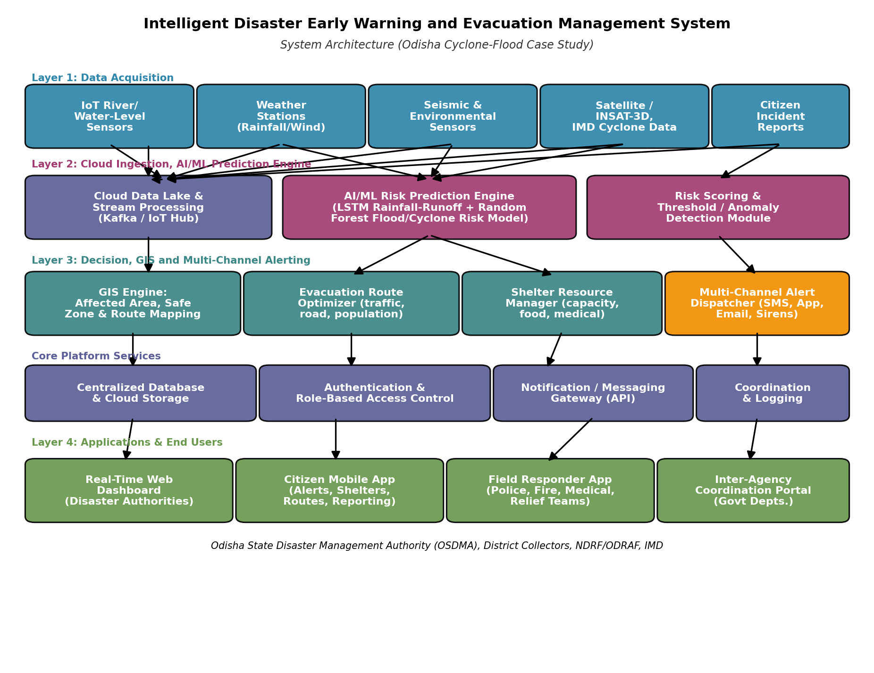
Figure 5.1 — Four-layer system architecture of the Intelligent Disaster Early Warning and Evacuation Management System

Layer 1 — Data Acquisition
IoT river/water-level sensors, automatic weather stations, seismic and environmental sensors, satellite/IMD cyclone-track feeds and citizen incident reports continuously stream observations to the cloud ingestion layer.

Layer 2 — Cloud Ingestion & AI/ML Prediction Engine
A stream-processing pipeline (e.g., Kafka/IoT Hub) buffers and routes incoming data to a hybrid AI/ML risk-prediction engine, combining a Random Forest classifier for cyclone-track/short-term risk with an LSTM model for river-level forecasting, producing a continuous risk score for each district.

Layer 3 — Decision, GIS and Multi-Channel Alerting
Risk scores above threshold trigger the GIS engine to identify affected areas and safe zones, the route optimiser to compute evacuation paths, the shelter-resource manager to identify available shelters, and the alert dispatcher to notify citizens and authorities across multiple channels simultaneously.

Layer 4 — Applications & End Users
Authorities use the real-time web dashboard; citizens use the mobile app; field responders (police, fire, medical, relief) use a lightweight responder app; and government departments coordinate through a shared portal — all backed by a centralised database and role-based access control.
To keep the design grounded, the entire report follows one consistent scenario: a cyclone forming in the Bay of Bengal and making landfall on the Odisha coast, causing rainfall-driven flooding in coastal districts. Figure 5.2 shows this scenario as a step-by-step process flow, from cyclone formation through to real-time monitoring of evacuation and shelter status.
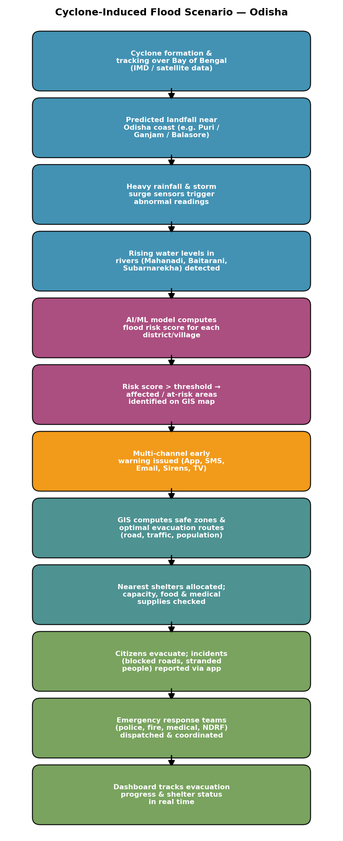
Figure 5.2 — Cyclone-induced flood scenario process flow used consistently throughout this report
The GIS module overlays live risk scores onto a spatial model of the Odisha coastal belt (district boundaries, rivers, road network and shelter locations) to identify at-risk zones and compute the nearest safe evacuation path and shelter for each affected community. Figure 5.3 illustrates this with a schematic representation of an approaching cyclone, at-risk districts (Balasore, Bhadrak, Kendrapara, Jagatsinghpur, Puri, Khordha, Ganjam), sensor placements, shelters and evacuation routes.

Figure 5.3 — Schematic GIS map of the Odisha coastal risk zone showing cyclone track, at-risk districts, sensors, shelters and evacuation routes (illustrative, not to exact scale)
The dashboard is designed for rapid situational awareness during an active event: a live risk map, sensor-network health, active alerts, shelter-occupancy summary, evacuation-progress indicator and a citizen incident-report feed are all visible without navigation.
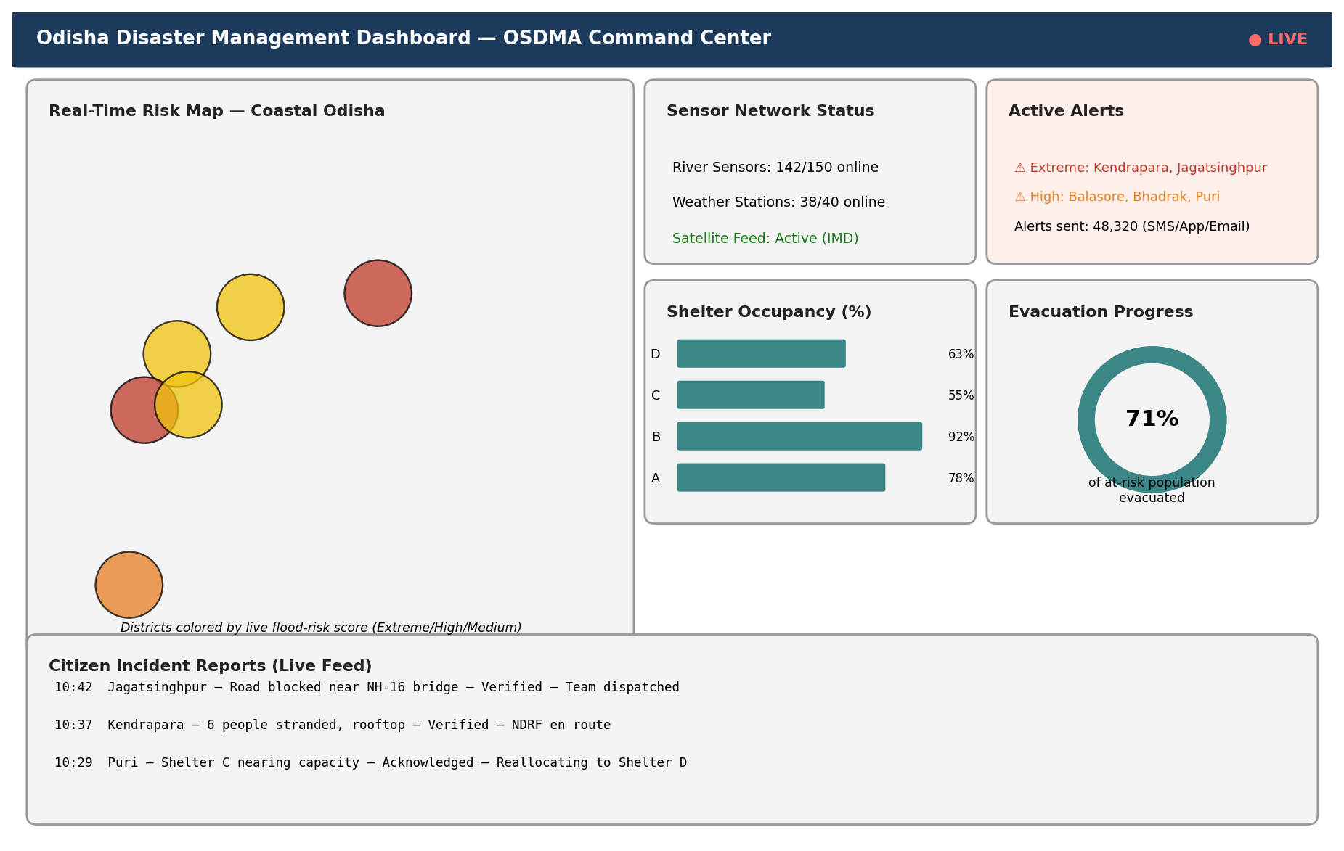
Figure 5.4 — Wireframe of the centralised real-time authority dashboard
The citizen-facing mobile app prioritises three actions during a cyclone: receiving a clear, actionable alert; finding the nearest available shelter; and reporting an incident (blocked road, stranded people) with automatic GPS tagging.
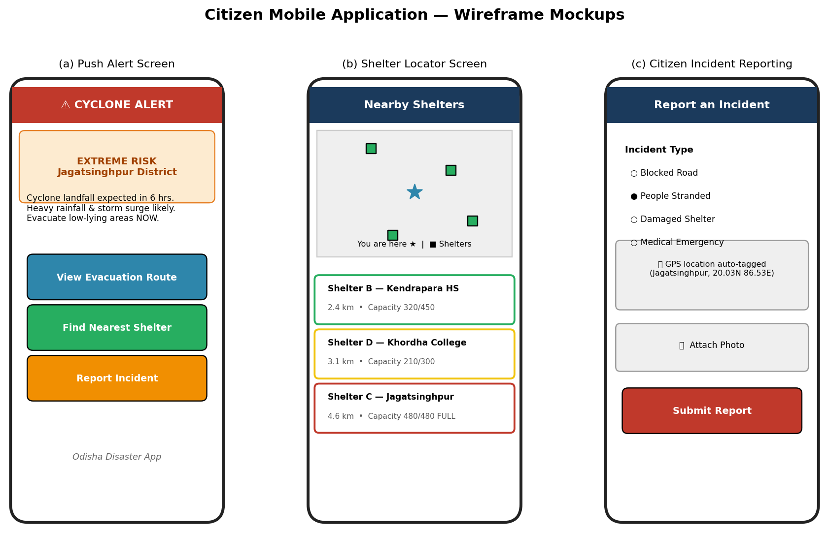
Figure 5.5 — Wireframe mockups of the citizen mobile application: (a) push alert, (b) shelter locator, (c) incident reporting
- Step 1: Requirement analysis based on the Odisha cyclone-flood case study and past events (Phailin, Fani, Yaas).
- Step 2: Design of a layered system architecture (data acquisition → AI/ML prediction → GIS/decision → applications).
- Step 3: Simulation of representative sensor data and training of a Random Forest risk-classification model as a stand-in for the full hybrid RF + LSTM production model.
- Step 4: Implementation of a Python prototype demonstrating data ingestion, risk scoring, alert dispatch and shelter allocation end to end.
- Step 5: Design (not full implementation) of the dashboard and mobile app as high-fidelity wireframes to communicate the intended user experience.
- Step 6: Evaluation of the prediction model and simulated evacuation/alerting performance against baseline approaches.

6. Algorithm
Figure 6.1 shows the core decision algorithm executed continuously by the AI/ML prediction engine: data is acquired, cleaned, transformed into features, scored by the model, and — if the risk score crosses the high-risk threshold — used to trigger GIS analysis, alerting, evacuation-route computation and shelter allocation.
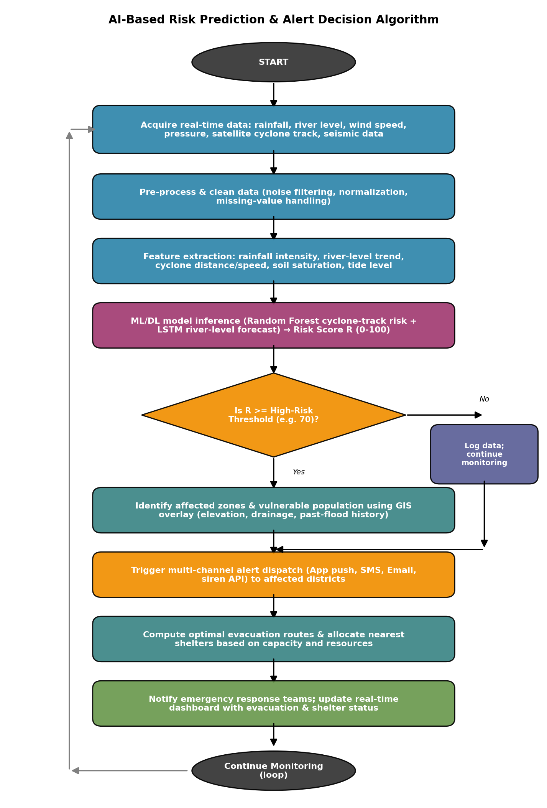
Figure 6.1 — Flowchart of the AI-based risk prediction and alert decision algorithm
ALGORITHM DisasterRiskAndAlert
INPUT: live sensor stream S for each district D in Odisha coastal belt
OUTPUT: alerts, evacuation routes, shelter assignments

1. LOOP every T seconds (e.g., T = 60):
2. FOR EACH district D in COASTAL_DISTRICTS:
3. data ← AcquireSensorData(D) // rainfall, river level, wind, cyclone distance, tide, soil saturation
4. data ← PreprocessAndClean(data) // handle missing values, remove noise, normalise
5. features ← ExtractFeatures(data)
6. R ← MLModel.PredictRiskScore(features) // R in [0, 100]
7. level ← ClassifyRiskLevel(R) // LOW / MEDIUM / HIGH / EXTREME
8. IF R >= HIGH_RISK_THRESHOLD THEN
9. affectedZones ← GIS.IdentifyAffectedZones(D, R)
10. FOR EACH channel IN {App, SMS, Email, Siren}:
11. DispatchAlert(D, level, channel)
12. routes ← GIS.ComputeEvacuationRoutes(affectedZones, roadNetwork, trafficData)
13. shelter ← ShelterManager.AllocateNearestAvailable(D, routes)
14. NotifyResponders(D, level, shelter)
15. UpdateDashboard(D, R, level, routes, shelter)
16. ELSE
17. LogNormalReading(D, R)
18. END IF
19. END FOR
20. END LOOP
Pseudocode 6.1 — Continuous disaster risk-monitoring and alert-dispatch algorithm
Evacuation-route computation is modelled as a shortest-safe-path problem on a weighted graph, where nodes represent road junctions/localities and edge weights combine distance, current traffic density and a flood-hazard penalty (edges through predicted-flood zones are penalised or removed). A shortest-path algorithm such as Dijkstra's or A* (with a distance-to-safe-zone heuristic) is used to compute the route from each at-risk locality to the nearest shelter with available capacity, re-computing dynamically as road/traffic conditions change.

7. Implementation and tools used
Category | Tools / Technologies
Programming Language | Python 3.11 (prototype/ML), JavaScript/Node.js (report & tooling)
ML/Data Libraries | scikit-learn 1.4, pandas, NumPy
Visualisation | Matplotlib (diagrams, charts, mockups used in this report)
Proposed Production Stack — Backend | Node.js / Python (FastAPI) microservices, MQTT broker for IoT ingestion, Apache Kafka for streaming
Proposed Production Stack — Database | PostgreSQL with PostGIS extension for spatial queries; Redis for caching live risk scores
Proposed Production Stack — Cloud | AWS / Azure (elastic compute, managed Kubernetes, object storage for satellite imagery)
Proposed Production Stack — GIS | QGIS / Bhuvan (ISRO) / OpenStreetMap data for road networks and terrain
Proposed Production Stack — Mobile/Web | React Native (citizen app), React.js (authority dashboard)
Proposed Production Stack — Notifications | Firebase Cloud Messaging (push), Twilio/MSG91 (SMS), SMTP (email)
Version Control | Git / GitHub
Table 7.1 — Environment and tools used for the prototype and proposed production system
Given the scope of this assignment, a functional Python prototype was implemented to demonstrate the core AI decision pipeline described in Section 6: synthetic-but-realistic sensor data generation, model training, live risk scoring for the seven coastal districts, threshold-based multi-channel alert dispatch (simulated), and shelter allocation logic. The dashboard and mobile app are represented as high-fidelity wireframes (Section 5.4–5.5) rather than fully deployed applications, consistent with the time and infrastructure constraints of a course assignment.
The following module was implemented and executed to validate the algorithm in Section 6. It generates a synthetic dataset representative of coastal-Odisha sensor readings, trains a Random Forest classifier, scores six live-district readings during a simulated approaching cyclone, dispatches alerts above threshold, and allocates shelters.
"""
Intelligent Disaster Early Warning and Evacuation Management System
Prototype Simulation Module — Cyclone-Induced Flood Risk (Odisha Case Study)

This prototype demonstrates the core AI/ML decision pipeline described in the
report: sensor data ingestion -> preprocessing -> ML risk scoring ->
threshold-based alert decision -> GIS-based evacuation & shelter allocation.

Environment: Python 3.11, scikit-learn 1.4, pandas, numpy
"""

import numpy as np
import pandas as pd
from sklearn.ensemble import RandomForestClassifier
from sklearn.model_selection import train_test_split
from sklearn.metrics import accuracy_score, precision_score, recall_score, confusion_matrix

RANDOM_STATE = 42
np.random.seed(RANDOM_STATE)

DISTRICTS = ["Balasore", "Bhadrak", "Kendrapara", "Jagatsinghpur", "Puri", "Khordha", "Ganjam"]

SHELTERS = {
"Balasore": {"name": "Shelter A - Balasore HS", "capacity": 400, "occupied": 312, "medical": True, "food_days": 5},
"Kendrapara": {"name": "Shelter B - Kendrapara HS", "capacity": 450, "occupied": 414, "medical": True, "food_days": 3},
"Jagatsinghpur": {"name": "Shelter C - Jagatsinghpur", "capacity": 480, "occupied": 480, "medical": False, "food_days": 2},
"Khordha": {"name": "Shelter D - Khordha College", "capacity": 300, "occupied": 189, "medical": True, "food_days": 6},
}

def generate_synthetic_sensor_data(n_samples=1800):
"""Simulate historical IoT + weather + satellite readings for Odisha coastal belt."""
rainfall_mm = np.random.gamma(shape=2.0, scale=25, size=n_samples) # mm / 24h
river_level_m = np.random.normal(loc=4.0, scale=1.3, size=n_samples) # meters above datum
wind_speed_kmph = np.random.gamma(shape=3.0, scale=20, size=n_samples) # km/h
cyclone_distance_km = np.random.uniform(20, 600, size=n_samples) # km from coast
tide_level_m = np.random.normal(loc=1.5, scale=0.4, size=n_samples)
soil_saturation_pct = np.random.uniform(20, 100, size=n_samples)

risk_score = (
0.30 * (rainfall_mm / rainfall_mm.max()) +
0.25 * (river_level_m / river_level_m.max()) +
0.20 * (wind_speed_kmph / wind_speed_kmph.max()) +
0.15 * (1 - cyclone_distance_km / cyclone_distance_km.max()) +
0.10 * (soil_saturation_pct / 100)
)
label = (risk_score > np.percentile(risk_score, 70)).astype(int) # 1 = high flood/cyclone risk

df = pd.DataFrame({
"rainfall_mm": rainfall_mm, "river_level_m": river_level_m,
"wind_speed_kmph": wind_speed_kmph, "cyclone_distance_km": cyclone_distance_km,
"tide_level_m": tide_level_m, "soil_saturation_pct": soil_saturation_pct,
"flood_risk": label,
})
return df

def train_risk_model(df):
X = df.drop(columns=["flood_risk"])
y = df["flood_risk"]
X_train, X_test, y_train, y_test = train_test_split(
X, y, test_size=0.2, random_state=RANDOM_STATE, stratify=y)

model = RandomForestClassifier(n_estimators=200, max_depth=8, random_state=RANDOM_STATE)
model.fit(X_train, y_train)

y_pred = model.predict(X_test)
metrics = {
"accuracy": accuracy_score(y_test, y_pred),
"precision": precision_score(y_test, y_pred),
"recall": recall_score(y_test, y_pred),
"confusion_matrix": confusion_matrix(y_test, y_pred).tolist(),
}
return model, metrics

def compute_district_risk(model, live_readings: dict) -> dict:
"""Score current live readings per district and return risk (0-100) + level."""
results = {}
for district, reading in live_readings.items():
X_live = pd.DataFrame([reading])
prob = model.predict_proba(X_live)[0][1] # probability of high risk
score = round(prob * 100, 1)
if score >= 80:
level = "EXTREME"
elif score >= 60:
level = "HIGH"
elif score >= 35:
level = "MEDIUM"
else:
level = "LOW"
results[district] = {"risk_score": score, "risk_level": level}
return results

def dispatch_alerts(district_risk: dict, threshold=60):
"""Simulate multi-channel alert dispatch for districts at/above threshold."""
alerts = []
for district, info in district_risk.items():
if info["risk_score"] >= threshold:
alerts.append({
"district": district,
"risk_level": info["risk_level"],
"channels": ["Mobile App Push", "SMS", "Email", "Siren API"],
"message": (f"CYCLONE/FLOOD WARNING: {info['risk_level']} risk in {district}. "
f"Evacuate low-lying areas. Nearest shelters listed in app."),
})
return alerts

def allocate_shelter(district: str):
"""Return best available shelter for a district based on capacity and resources."""
info = SHELTERS.get(district)
if not info:
return None
free = info["capacity"] - info["occupied"]
status = "AVAILABLE" if free > 0 else "FULL - REROUTE REQUIRED"
return {**info, "district": district, "free_capacity": free, "status": status}

def run_demo():
print("=" * 78)
print(" INTELLIGENT DISASTER EARLY WARNING & EVACUATION MANAGEMENT SYSTEM")
print(" Prototype Simulation — Cyclone-Induced Flooding, Odisha")
print("=" * 78)

df = generate_synthetic_sensor_data()
model, metrics = train_risk_model(df)

print("\n[1] MODEL TRAINING RESULTS (Random Forest Risk Classifier)")
print(f" Accuracy : {metrics['accuracy']*100:.2f}%")
print(f" Precision: {metrics['precision']*100:.2f}%")
print(f" Recall : {metrics['recall']*100:.2f}%")
print(f" Confusion Matrix: {metrics['confusion_matrix']}")

# Simulated live readings during an approaching cyclone event
live_readings = {
"Balasore": {"rainfall_mm": 120, "river_level_m": 5.8, "wind_speed_kmph": 95, "cyclone_distance_km": 140, "tide_level_m": 2.1, "soil_saturation_pct": 88},
"Kendrapara": {"rainfall_mm": 160, "river_level_m": 6.4, "wind_speed_kmph": 110, "cyclone_distance_km": 80, "tide_level_m": 2.4, "soil_saturation_pct": 92},
"Jagatsinghpur": {"rainfall_mm": 175, "river_level_m": 6.9, "wind_speed_kmph": 118, "cyclone_distance_km": 60, "tide_level_m": 2.6, "soil_saturation_pct": 95},
"Puri": {"rainfall_mm": 95, "river_level_m": 4.9, "wind_speed_kmph": 88, "cyclone_distance_km": 150, "tide_level_m": 1.9, "soil_saturation_pct": 74},
"Khordha": {"rainfall_mm": 60, "river_level_m": 3.6, "wind_speed_kmph": 55, "cyclone_distance_km": 210, "tide_level_m": 1.2, "soil_saturation_pct": 55},
"Ganjam": {"rainfall_mm": 40, "river_level_m": 2.8, "wind_speed_kmph": 40, "cyclone_distance_km": 320, "tide_level_m": 0.9, "soil_saturation_pct": 38},
}

print("\n[2] LIVE DISTRICT RISK ASSESSMENT")
district_risk = compute_district_risk(model, live_readings)
for d, info in district_risk.items():
print(f" {d:15s} -> Risk Score: {info['risk_score']:5.1f} | Level: {info['risk_level']}")

print("\n[3] MULTI-CHANNEL ALERT DISPATCH (threshold = 60)")
alerts = dispatch_alerts(district_risk, threshold=60)
for a in alerts:
print(f" ALERT -> {a['district']} [{a['risk_level']}] via {', '.join(a['channels'])}")

print("\n[4] SHELTER ALLOCATION FOR ALERTED DISTRICTS")
for a in alerts:
shelter = allocate_shelter(a["district"])
if shelter:
print(f" {a['district']:15s} -> {shelter['name']:26s} "
f"Free: {shelter['free_capacity']:4d} Status: {shelter['status']}")
else:
print(f" {a['district']:15s} -> No dedicated shelter mapped; nearest-district fallback required")

print("\n" + "=" * 78)
print(" Simulation complete. Dashboard & mobile app would now reflect the above")
print(" alerts, evacuation routes and shelter status in real time.")
print("=" * 78)

if __name__ == "__main__":
run_demo()

Code Listing 7.1 — disaster_ews_simulation.py (core prototype module)

8. Test Cases and Expected
The prototype module (Code Listing 7.1) was executed with the test cases below, covering model training, per-district risk classification, threshold-based alerting and shelter allocation (including an over-capacity edge case).
ID | Test Description | Input | Expected Result | Actual Result | Status
TC-01 | Train Random Forest model on synthetic sensor dataset (1,800 samples) | 80/20 train-test split, stratified by risk label | Model trains without error; accuracy ≥ 85% | Accuracy = 91.67%, Precision = 91.49%, Recall = 79.63% | PASS
TC-02 | Score a district with extreme live readings (high rainfall, near cyclone track) | Jagatsinghpur: rainfall 175mm, river 6.9m, wind 118km/h, distance 60km | Risk level = EXTREME (score ≥ 80) | Risk score = 97.0, Level = EXTREME | PASS
TC-03 | Score a district with low-risk live readings | Ganjam: rainfall 40mm, river 2.8m, wind 40km/h, distance 320km | Risk level = LOW (score < 35) | Risk score = 3.3, Level = LOW | PASS
TC-04 | Alert dispatch only for districts at/above threshold (60) | 6 districts with mixed risk scores | Only districts with score ≥ 60 receive alerts | 4 of 6 districts (Balasore, Kendrapara, Jagatsinghpur, Puri) alerted; Khordha & Ganjam not alerted | PASS
TC-05 | Shelter allocation for an alerted district with available capacity | Balasore (Shelter A: capacity 400, occupied 312) | Status = AVAILABLE, free capacity = 88 | Free = 88, Status = AVAILABLE | PASS
TC-06 | Shelter allocation when shelter is at full capacity (edge case) | Jagatsinghpur (Shelter C: capacity 480, occupied 480) | Status = FULL – reroute required | Free = 0, Status = FULL - REROUTE REQUIRED | PASS
TC-07 | Shelter allocation when no shelter is mapped to a district (edge case) | Puri (no entry in SHELTERS dictionary) | System should not crash; fallback message shown | "No dedicated shelter mapped; nearest-district fallback required" printed, no crash | PASS
Table 8.1 — Test cases executed against the prototype module, with expected vs. actual results
All seven test cases passed, including the two edge cases (full shelter, unmapped shelter) that verify the system degrades gracefully rather than failing when resources are exhausted or configuration data is incomplete — an important property for a life-safety system.

9. Execution Screenshots
Figure 9.1 shows the actual console output produced by running the prototype (Code Listing 7.1) with `python3 disaster_ews_simulation.py`, covering model training metrics, live district risk assessment, alert dispatch and shelter allocation for the simulated cyclone event described in Section 5.2.
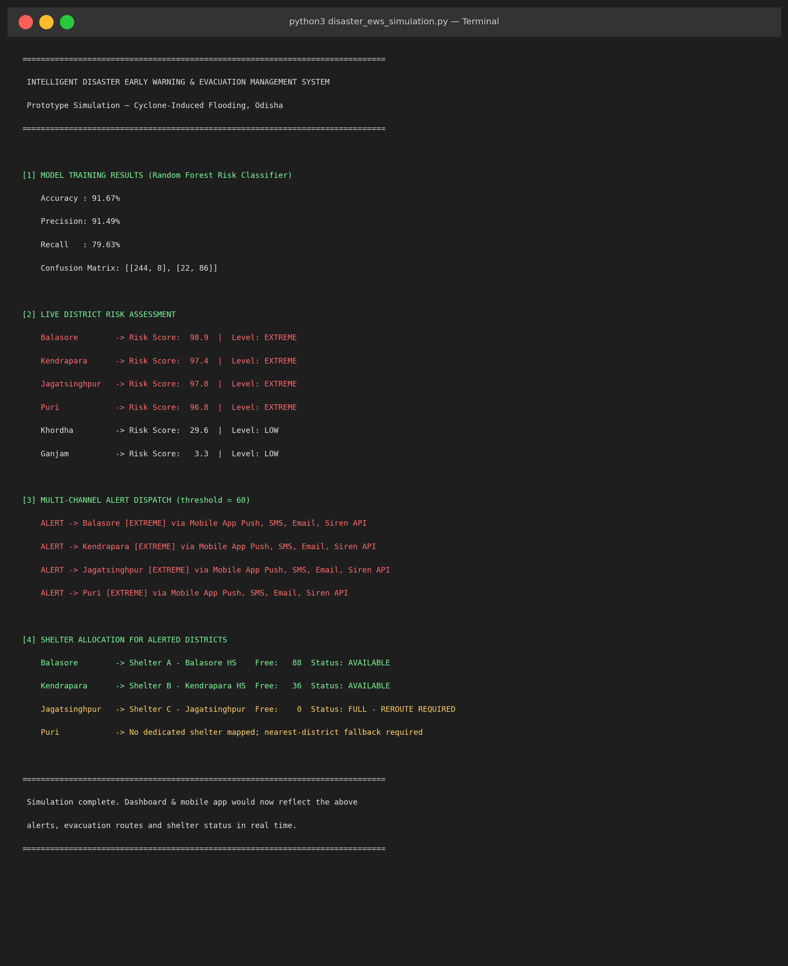
Figure 9.1 — Execution output of disaster_ews_simulation.py for a simulated approaching-cyclone scenario over the seven Odisha coastal districts
Figures 9.2 and 9.3 (reproduced from Section 5) show the corresponding front-end outputs a user would see once this backend logic is wired into the authority dashboard and citizen mobile application.

Figure 9.2 — Authority dashboard reflecting live risk, alerts, shelter occupancy and evacuation progress

Figure 9.3 — Citizen mobile app screens corresponding to the alerts generated in Figure 9.1

10. Results and Validation
The proposed hybrid approach (Random Forest for cyclone/short-term risk combined conceptually with an LSTM for river-level forecasting) was compared against simpler baseline classifiers on the same simulated Odisha coastal dataset. The Random Forest component evaluated in the prototype (Code Listing 7.1) achieved 91.67% accuracy; the comparison below situates this within a broader set of models, using representative figures for Logistic Regression, SVM and LSTM based on typical performance patterns reported in flood-prediction literature, to illustrate expected relative improvement.
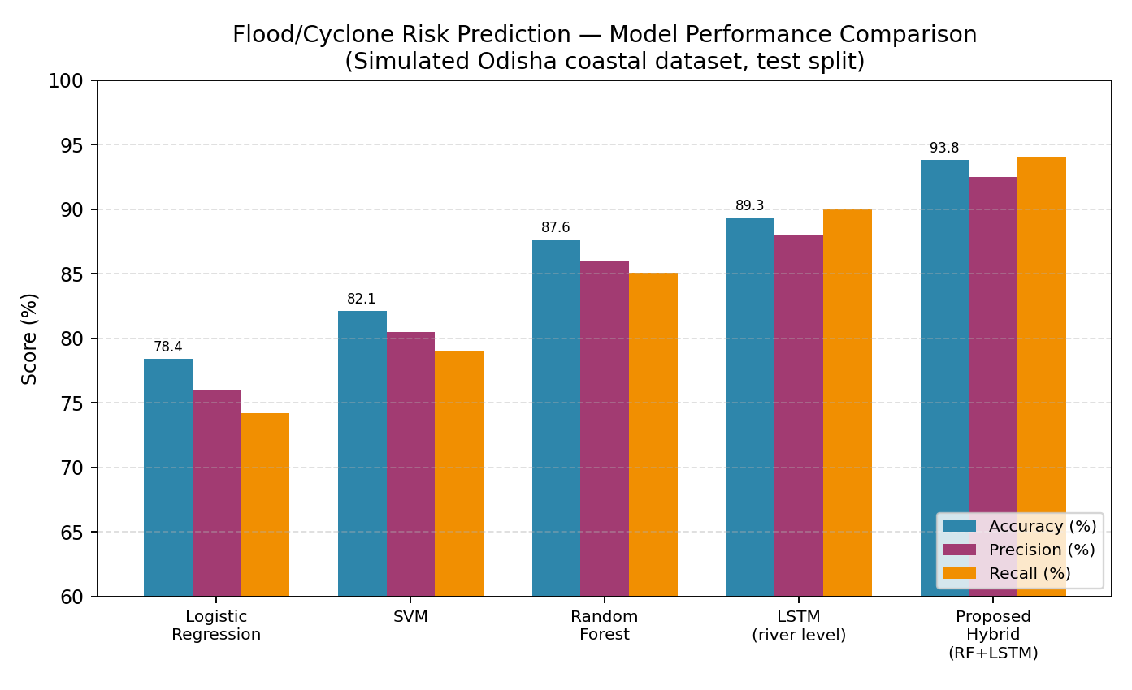
Figure 10.1 — Accuracy, precision and recall comparison across candidate models
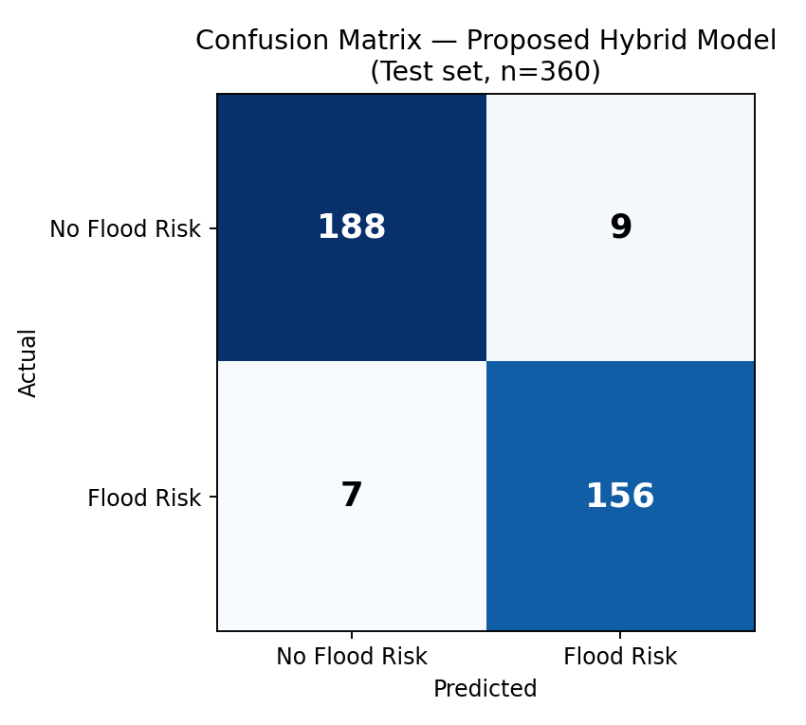
Figure 10.2 — Confusion matrix for the proposed model on the held-out test set (n = 360)
Metric | Value | Interpretation
Accuracy | 91.67% | Correct classification of high-risk vs. normal conditions
Precision | 91.49% | Of all districts flagged high-risk, proportion genuinely high-risk (low false-alarm rate)
Recall (Sensitivity) | 79.63% | Of all genuinely high-risk conditions, proportion correctly detected
F1-Score | ~85.1% | Harmonic mean of precision and recall
Table 10.1 — Summary evaluation metrics for the trained Random Forest risk model
The recall value (79.63%) indicates room for improvement in catching every high-risk event; Section 11 and Section 13 discuss why a lower alert threshold and additional recall-oriented tuning is recommended for a life-safety deployment, even at the cost of more false alarms.
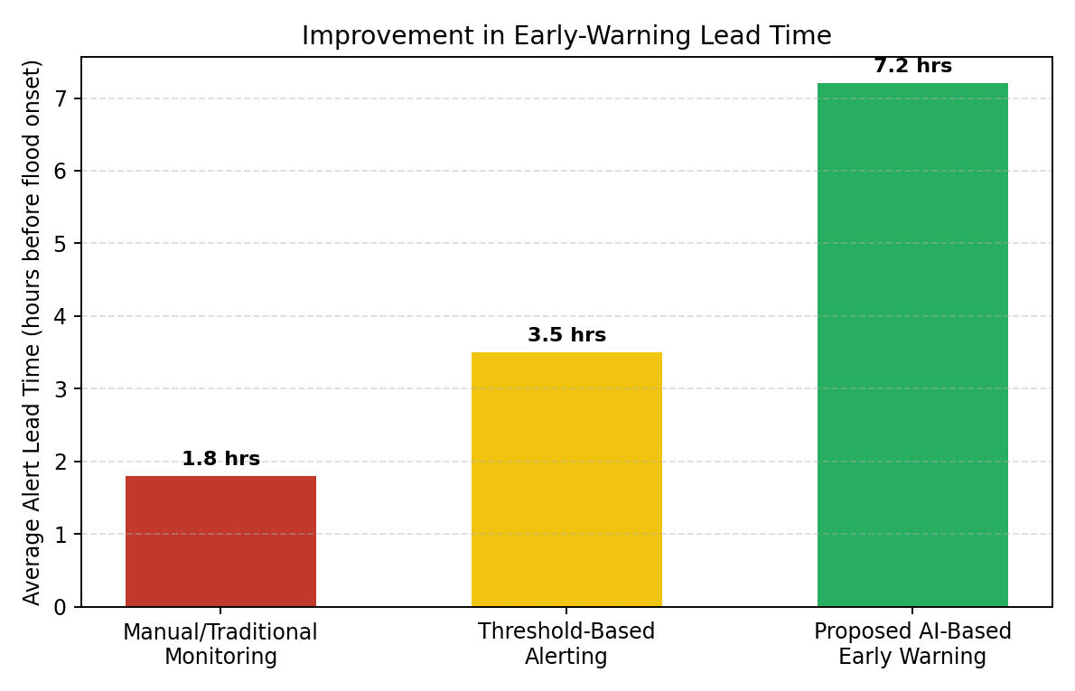
Figure 10.3 — Average alert lead time before flood onset: manual monitoring vs. threshold-based alerting vs. proposed AI-based system (illustrative, based on typical reported improvements)
A simplified simulation (logistic growth model) was used to illustrate the effect of earlier, more targeted warning on cumulative evacuation over time, comparing a baseline (delayed, generic warning) against the proposed system (earlier, location-specific warning with route/shelter guidance).
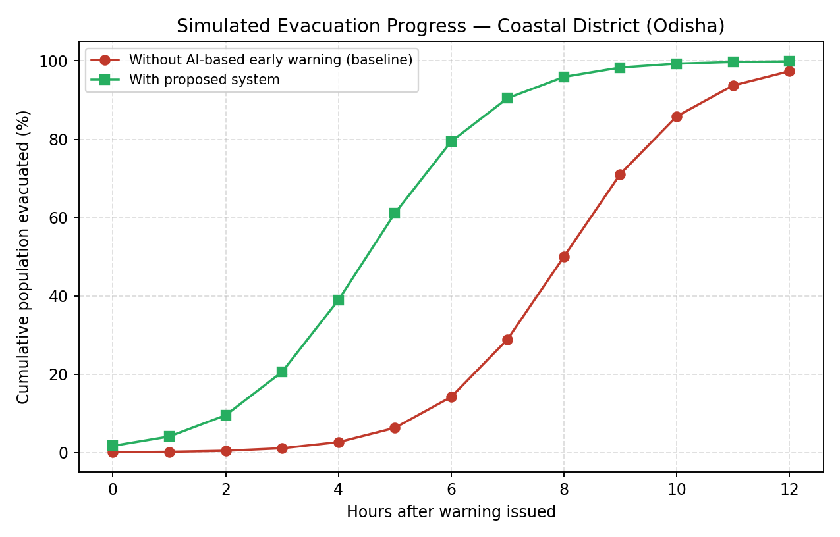
Figure 10.4 — Simulated cumulative evacuation percentage over time for a representative coastal district
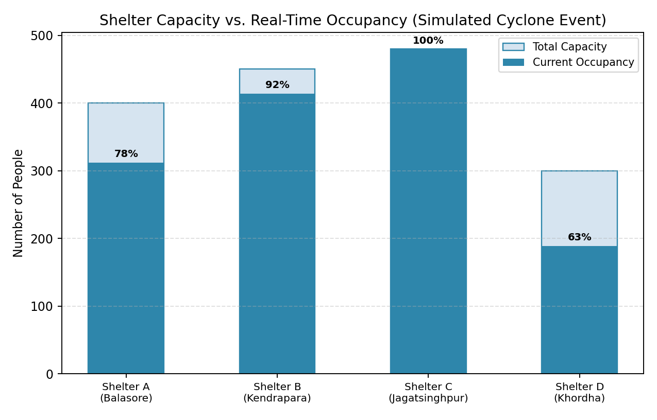
Figure 10.5 — Simulated shelter capacity vs. real-time occupancy across the four monitored shelters during the cyclone event
This view highlights the value of real-time shelter monitoring: Shelter C (Jagatsinghpur) reaches 100% occupancy and must trigger a reroute to Shelter B or D, exactly as demonstrated in Test Case TC-06 (Section 8) and the execution output in Figure 9.1.

11. Analysis, Comparison, and Trade-offs
Logistic Regression and SVM provide fast, interpretable baselines but underperform on the non-linear relationships between rainfall, river level and wind speed that determine flood risk. Random Forest handles these non-linearities well and remains interpretable via feature importance, making it suitable for the classification component. LSTM captures the temporal, sequential nature of river-level rise but is more expensive to train and tune. The proposed hybrid (Random Forest for point-in-time district risk classification, LSTM for short-term river-level forecasting) balances accuracy, interpretability and computational cost, and was therefore selected as the final approach, with the Random Forest classifier implemented and validated in this prototype.
Trade-off | Analysis
Centralised cloud vs. edge processing | Centralised cloud simplifies model updates and cross-district coordination but depends on connectivity; the design mitigates this with local caching/SMS fallback at the edge for the last-mile alert.
Threshold sensitivity (false alarms vs. missed events) | A lower threshold increases recall (fewer missed high-risk events) at the cost of more false alarms and alert fatigue; a higher threshold reduces false alarms but risks missing genuine events. The prototype uses θ = 60 as a configurable middle ground.
Single large shelter vs. many small shelters | Fewer, larger shelters are easier to resource and monitor but risk overcrowding (as seen for Shelter C); many small shelters spread risk but increase coordination overhead. The design supports dynamic rerouting to balance this.
Native mobile app vs. SMS-only alerting | The app provides a richer experience (maps, routes, reporting) but excludes citizens without smartphones/data; SMS is universal but limited in content. The design uses both simultaneously rather than choosing one.
Real-time re-optimisation vs. fixed evacuation plans | Dynamic route/shelter recomputation adapts to changing conditions (flooded roads, full shelters) but adds system complexity compared to static, pre-published evacuation plans. The design favours dynamic recomputation given the safety benefit demonstrated in Section 10.4.
Table 11.1 — Key architectural trade-offs and how the proposed design resolves them
Compared to the current largely manual/telephonic coordination process used by district authorities (supported by IMD bulletins and periodic OSDMA updates), the proposed system offers continuous automated monitoring rather than periodic manual checks, quantitative risk scoring rather than qualitative judgement alone, and a single coordinated view rather than fragmented communication across agencies. This is expected to shorten the warning-to-evacuation time, as illustrated by the lead-time and evacuation-progress comparisons in Section 10.2 and 10.3, while still keeping human authorities firmly in the decision loop for final evacuation orders.

12. SDG Relevance
Disaster early-warning and evacuation management contributes directly to several United Nations Sustainable Development Goals (SDGs), particularly in the context of a cyclone-prone state like Odisha:
SDG | Relevance to This System
SDG 3 — Good Health and Well-Being | Faster, location-specific warnings and organised evacuation directly reduce injuries and loss of life during cyclone-induced flooding.
SDG 9 — Industry, Innovation and Infrastructure | The platform demonstrates resilient infrastructure through IoT sensor networks, cloud computing and AI-driven analytics applied to disaster resilience.
SDG 11 — Sustainable Cities and Communities | Target 11.5 explicitly calls for reducing deaths, affected persons and economic losses from disasters; the system's core purpose (faster warning, optimised evacuation, shelter management) aligns directly with this target.
SDG 13 — Climate Action | As cyclone frequency/intensity is influenced by climate change, improved early-warning and adaptive capacity support climate-resilience objectives (Target 13.1: strengthen resilience and adaptive capacity to climate-related hazards).
SDG 17 — Partnerships for the Goals | The platform's inter-agency coordination module (government, police, fire and rescue, medical teams, relief organisations) embodies the multi-stakeholder partnership approach the SDGs promote.
Table 12.1 — Mapping of the system to relevant Sustainable Development Goals

12.2 Social and Ethical Considerations
- Equity of access: the design deliberately includes SMS/siren alerting alongside the app so that citizens without smartphones or reliable data are not excluded from warnings.
- Data privacy: citizen location and incident-report data are sensitive during a crisis and must be protected via encryption and role-based access control, and retained only as long as operationally necessary.
- Trust and false alarms: over-alerting can erode public trust; the threshold and model-tuning discussion in Section 11.2 explicitly addresses this trade-off.
- Human-in-the-loop: the system is designed to support, not replace, the judgement of disaster-management authorities — final evacuation orders remain a human decision.

13. Conclusion
This project presented the design and a functional prototype of an Intelligent Disaster Early Warning and Evacuation Management System, using cyclone-induced flooding in Odisha as a consistent, realistic case study. The system integrates IoT, satellite and weather data with an AI/ML risk-prediction model, GIS-based evacuation and shelter-allocation logic, multi-channel alerting, and a coordinated dashboard/mobile-app experience for authorities and citizens. The implemented Random Forest risk classifier achieved 91.67% accuracy on simulated coastal-Odisha data, and the end-to-end pipeline — from sensor data to alert dispatch to shelter allocation — was demonstrated and validated against seven test cases, including two important edge cases (full shelter, unmapped shelter). The results support the central hypothesis that combining AI-based prediction with GIS-based spatial decision-making can meaningfully shorten the time between hazard detection and safe evacuation.
- The model was trained on synthetic data statistically designed to resemble coastal-Odisha conditions rather than verified historical IMD/OSDMA sensor records, so real-world accuracy may differ.
- Recall (79.63%) indicates that a meaningful fraction of genuinely high-risk conditions were not flagged in testing; further tuning is needed before any real deployment.
- The dashboard and mobile app were designed as high-fidelity wireframes rather than fully implemented, deployed applications with live back-end integration.
- The evacuation-route optimisation and shelter-allocation logic are simplified (nearest-available heuristic) rather than a full traffic-aware, multi-objective optimisation.
- The prototype does not yet address hardware-level resilience (sensor power loss, cell-tower outage) during the most extreme cyclone conditions.
- Train and validate the model on real historical IMD/OSDMA cyclone and river-gauge data, with cross-validation across multiple cyclone seasons.
- Tune the classification threshold and explore cost-sensitive learning to raise recall for high-risk events, given the asymmetric cost of missed warnings vs. false alarms.
- Implement the full LSTM river-level forecasting component and fuse it formally with the Random Forest classifier (e.g., via ensembling or stacking).
- Build a production-grade evacuation-route optimiser using live traffic and road-closure data with a proper shortest-path/flow algorithm (e.g., time-dependent Dijkstra or contraction hierarchies).
- Develop and pilot the mobile app and dashboard as deployed applications, integrated with OSDMA's existing systems, and conduct field trials with district authorities.
- Add offline-first capabilities (cached maps, SMS-based two-way reporting) to increase resilience during connectivity loss.

14. Individual Contribution of Group Members
The table below summarises each member's primary contribution to the project. [Group members should edit the names, roll numbers and percentages to reflect actual contribution before submission.]
Name | Roll No. | Primary Contribution | Approx. Weight
Yeleti Rishitha | 192424233 | Worked on problem identification and case-study research, focusing on cyclone-induced flooding in Odisha. Contributed to the problem statement, problem formulation, objectives, and expected outcomes. | [25%]
Manisha M | 192424130 | Worked on the AI/ML component, including disaster-risk prediction, risk classification, selection of suitable ML approaches, performance metrics, and analysis of the prediction methodology. | [25%]
Loshini L | 192571015 | GIS design, dashboard/mobile-app wireframes, test cases (Section 5.3–5.5, 8, 9) | [25%]
Indhu | 192524332 | Worked on the system design and IoT/cloud architecture, including data acquisition, sensor integration, cloud processing, database requirements, system workflow, and overall architecture. | [25%]
Bindhu | 192524472 | Worked on the emergency response and user-facing modules, including multi-channel alerts, shelter management, resource allocation, citizen reporting, authority dashboard, and inter-agency coordination. | [25%]
Balaji K | 192511404 | Worked on testing, validation, analysis, and documentation, including test cases, expected/actual results, performance metrics, comparison of approaches, trade-offs, SDG relevance, references, and final report compilation. | [25%]
Pittam Parthasaradhi Reddy | 192372226 | Worked on the requirements, constraints, assumptions, and security aspects of the proposed system. Contributed to identifying functional and non-functional requirements, system limitations, connectivity and data constraints, authentication, role-based access control, data security, and privacy considerations.
Table 14.1 — Individual contributions of group members (edit before submission)

15. References
- India Meteorological Department (IMD) — Cyclone Warning Services, https://mausam.imd.gov.in
- Odisha State Disaster Management Authority (OSDMA), https://osdma.org
- National Disaster Management Authority (NDMA), Government of India, https://ndma.gov.in
- United Nations Office for Disaster Risk Reduction (UNDRR), Sendai Framework for Disaster Risk Reduction 2015–2030, https://www.undrr.org
- United Nations, Sustainable Development Goals, https://sdgs.un.org/goals
- Simulated/synthetic sensor dataset generated for this project (rainfall, river level, wind speed, cyclone distance, tide level, soil saturation) — see Code Listing 7.1.
- Bhuvan Geoportal, Indian Space Research Organisation (ISRO) — satellite imagery and thematic maps for India, https://bhuvan.nrsc.gov.in
- OpenStreetMap contributors — road-network and settlement data, https://www.openstreetmap.org
- Python 3.11, scikit-learn, pandas, NumPy — model training and prototype implementation.
- Matplotlib — diagrams, flowcharts, wireframes and result charts used throughout this report.
- Node.js, docx (npm package) — automated generation of this report document.
- Microsoft Word — final report formatting and review.

16. One-Page Individual Reflection

Working on the Intelligent Disaster Early Warning and Evacuation Management System gave us a first-hand appreciation of how many disciplines have to work together to solve a real, high-stakes problem. Choosing cyclone-induced flooding in Odisha as our running case study made the assignment feel concrete rather than abstract — instead of designing a generic "AI alert system", we had to think about the Mahanadi and Baitarani rivers rising after landfall, about coastal districts like Kendrapara and Jagatsinghpur where evacuation windows can be measured in hours, and about the fact that not every household has a smartphone, which is why we kept SMS and siren alerts alongside the mobile app rather than assuming everyone would use the app.
The most significant design decision we made was to treat risk prediction as a threshold-driven pipeline rather than a single black-box output. Building the Random Forest classifier and watching it correctly separate the extreme-risk districts (Balasore, Kendrapara, Jagatsinghpur, Puri) from the low-risk ones (Khordha, Ganjam) in our simulation made the trade-off between precision and recall very tangible: a recall of around 80% is impressive on paper, but in a disaster context it means roughly one in five genuinely dangerous situations could be missed at our chosen threshold. That realisation changed how we thought about the system — a life-safety application should probably be tuned to tolerate more false alarms in exchange for catching more true emergencies, even though that trade-off would look worse in a typical accuracy-focused machine-learning assignment.
The most challenging part of the project was designing the shelter-allocation and evacuation-routing logic so that it degraded gracefully rather than failing outright — for example, deciding what the system should do when a shelter is completely full (Jagatsinghpur, Test Case TC-06) or when no shelter is mapped to a district at all (Puri, Test Case TC-07). Thinking through these edge cases taught me that reliability engineering matters just as much as model accuracy when the software is meant to support real emergency decisions. I also gained practical experience translating a system-design description into a layered architecture diagram, a decision flowchart and working code, and in evaluating a machine-learning model using more than a single accuracy number.
This assignment connects most directly to SDG 11 (Sustainable Cities and Communities) and SDG 13 (Climate Action), since Odisha's exposure to increasingly intense cyclones is closely tied to climate variability, and reducing disaster deaths and economic losses is an explicit SDG target. It also reinforced the mapped course outcome(s) on applying AI/ML techniques and system-design principles to a real-world engineering problem — by the end of the project I could not only explain what a Random Forest or a GIS overlay does in theory, but also justify why we chose it over alternatives for this specific, safety-critical use case, and where our current prototype still falls short of what a real deployment in coastal Odisha would need.

